* **Image Scrapper Assignment Screenshots**

<Screenshot 1> Run window

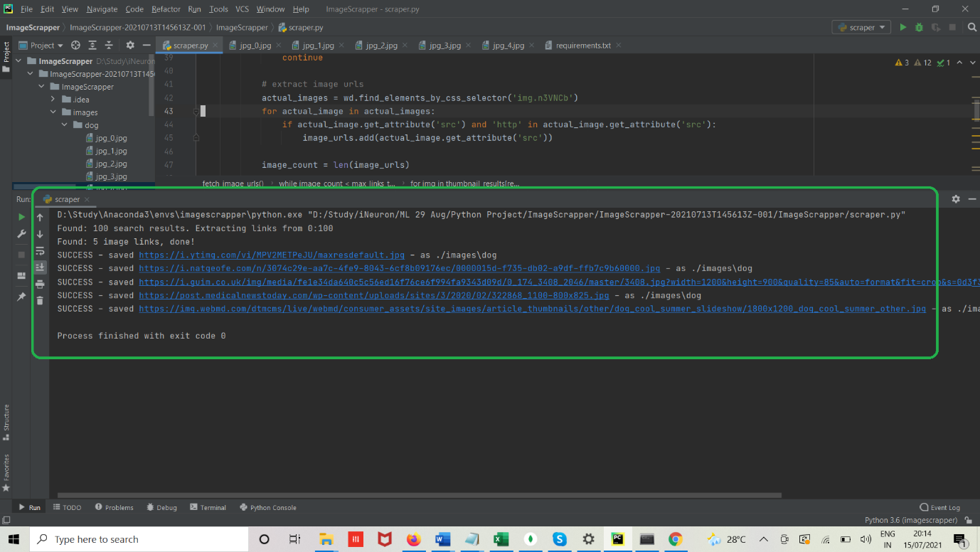

<Screenshot 2> Image folder: dog folder and dog images

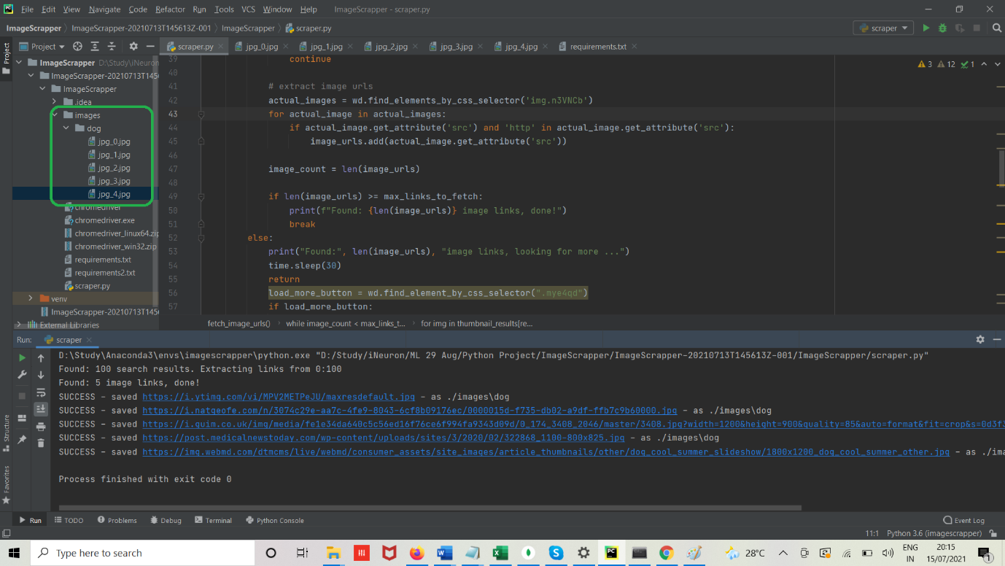

<Screenshot 3> Dog image 1

<Screenshot 4> Dog image 2

<Screenshot 5> Dog image 3

<Screenshot 6> Dog image 4

<Screenshot 7> Dog image 5

